Data Analytics with Tableau – Assignment 2
Team ID: LTVIP2026TMIDS28502
Donut Chart – Sales by Payment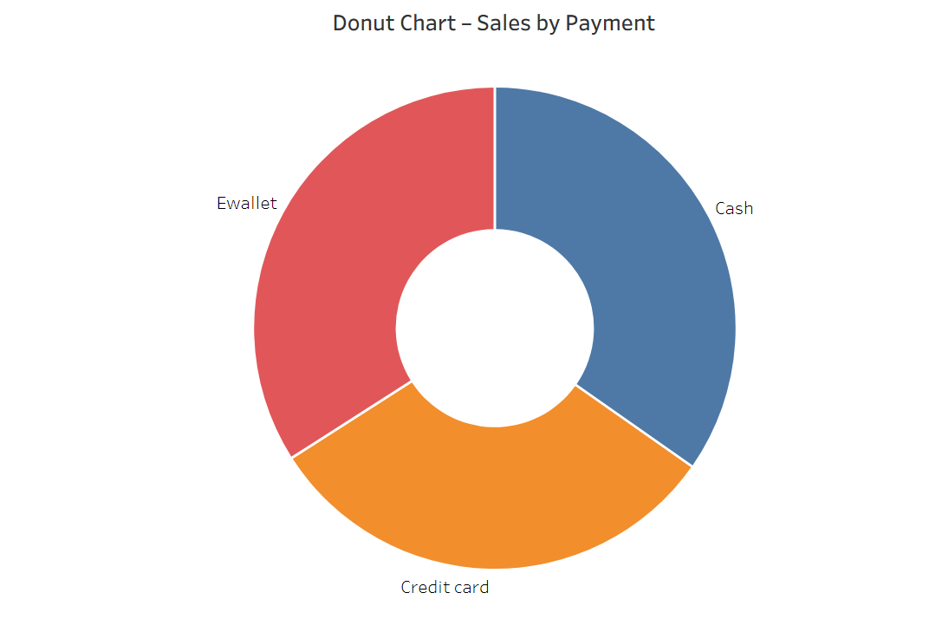

Area Chart – Sales Trend by Product Line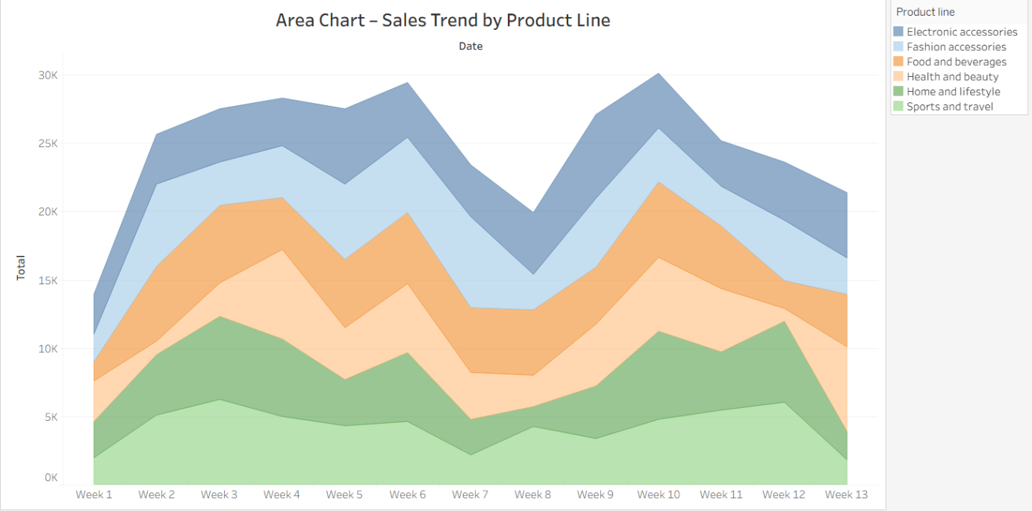

Text Table – Sales by Branch and Product Line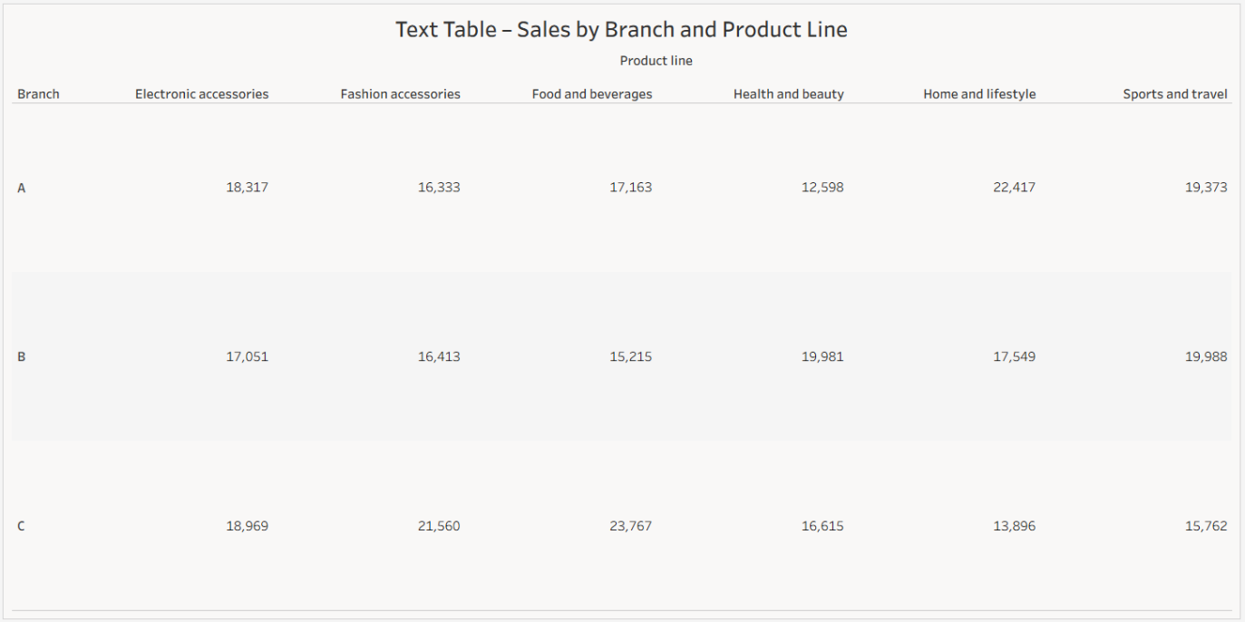

Highlighted Table – Sales by Branch and Product Line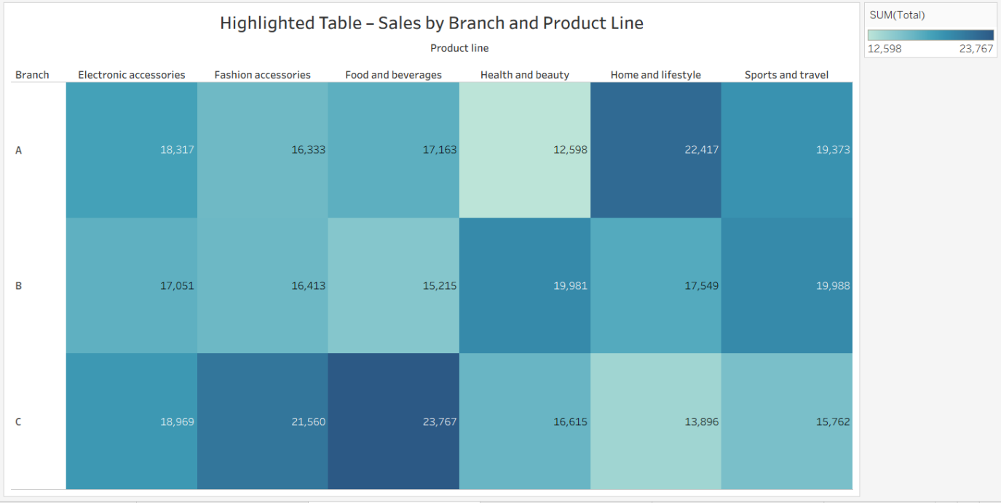

Word Cloud – Sales by Product Line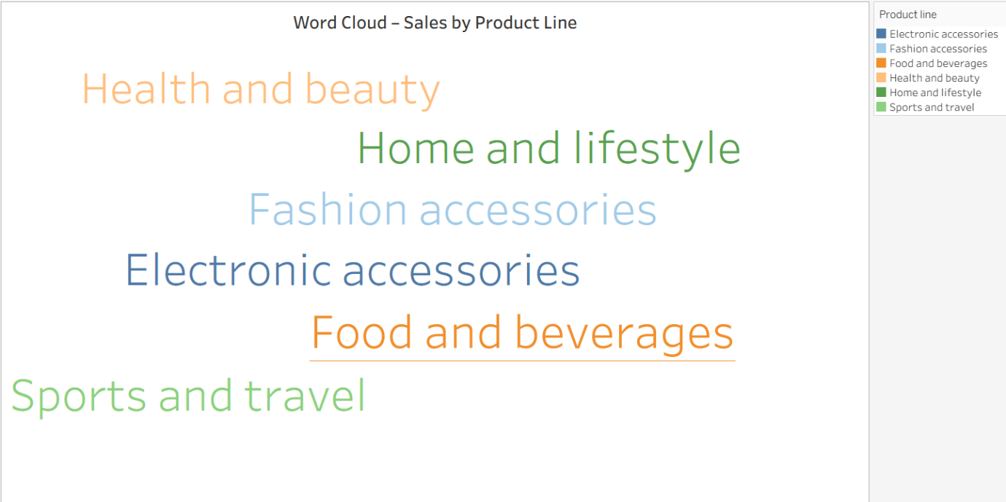

Funnel Chart – Sales by Product Line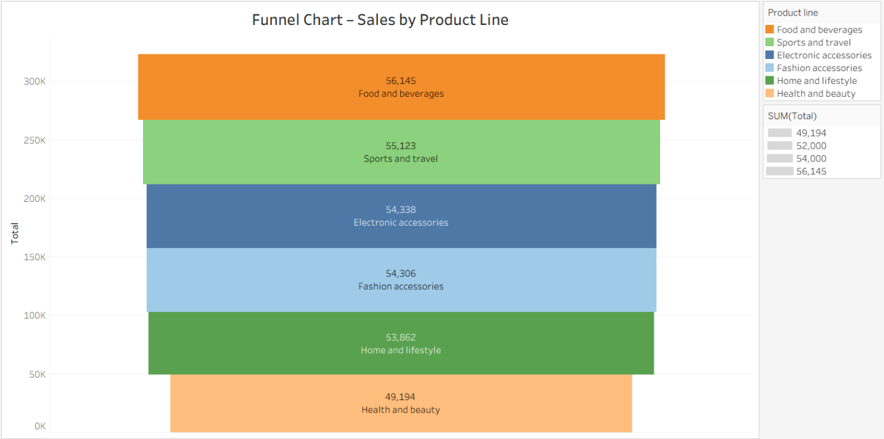

Waterfall Chart – Sales by Product Line